**Logic App Secure File Transfer Lab Guide**

**Build an Azure Logic App that will automate data processing for structured JSON files and parse JSON objects in a workflow that triggers when a file is uploaded in Azure Storage and results in the desired JSON objects to securely transfer to a SharePoint list.**

**This Lab guide will provide proficiency in the workflows Azure Logic Apps can perform, reducing the burden of manual labor involving data by integrating automation processing.**

**Pre-requisites**

* **An Azure subscription.**
* **An M365 subscription.**
* **An Azure Storage Account deployed with private endpoint connectivity.**
* **A Key Vault resource deployed with private endpoint and RBAC access configured.**
* **An Azure Logic App deployed (consumption) with system assigned managed identity enabled and the following RBAC roles assigned:**
  + **Storage Blob Data Contributor scoped at storage resource.**
  + **Key Vault Secrets User scoped at key vault resource.**
* **A SharePoint site configured with an active user account.**

**BEGIN LOGIC APP LAB**

1. Login to your Azure subscription and search for the existing Azure Logic App consumption type that was deployed.
2. On the Logic App resource left pane, click on Logic App Designer.
3. Scroll down and click on ‘+ Blank Logic App’.

**Note:** Start building the Logic App by selecting the trigger. Follow the steps below to complete. At the end the Logic App designer will look like the example screenshot below.

1. Select the Trigger **‘**When a blob is added or modified (properties only) (V2)’.

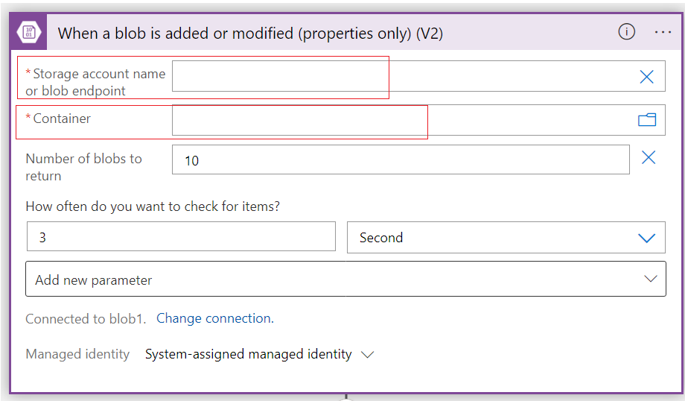

|  |  |
| --- | --- |
| Storage Account Name or Blob Endpoint | <your storage account name> |
| Container | <container name> |

1. Select the Action ‘Get blob content (V2)’.

* Add dynamic content to select ‘List of Files Display Name’. Example provided in screenshot below.

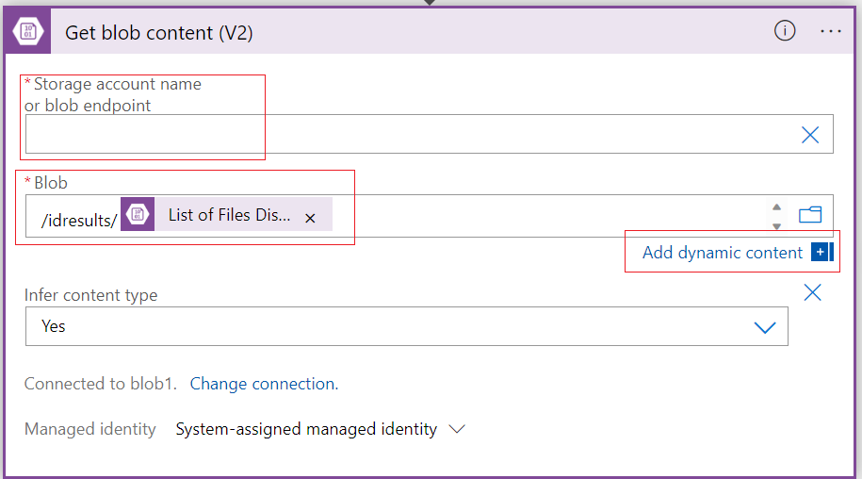

|  |  |
| --- | --- |
| Storage Account Name or Blob Endpoint | <your storage account name> |
| Blob | <container path>/List of Files Display Name |

1. Select the Action ‘ParseJSON’.

* On ‘add dynamic content’, select expression and search for ‘json()’, then add ‘Get blob content’ from dynamic content as a parameter.
* Select ‘Use sample payload to generate schema’, enter or paste a sample JSON payload, and click Done.

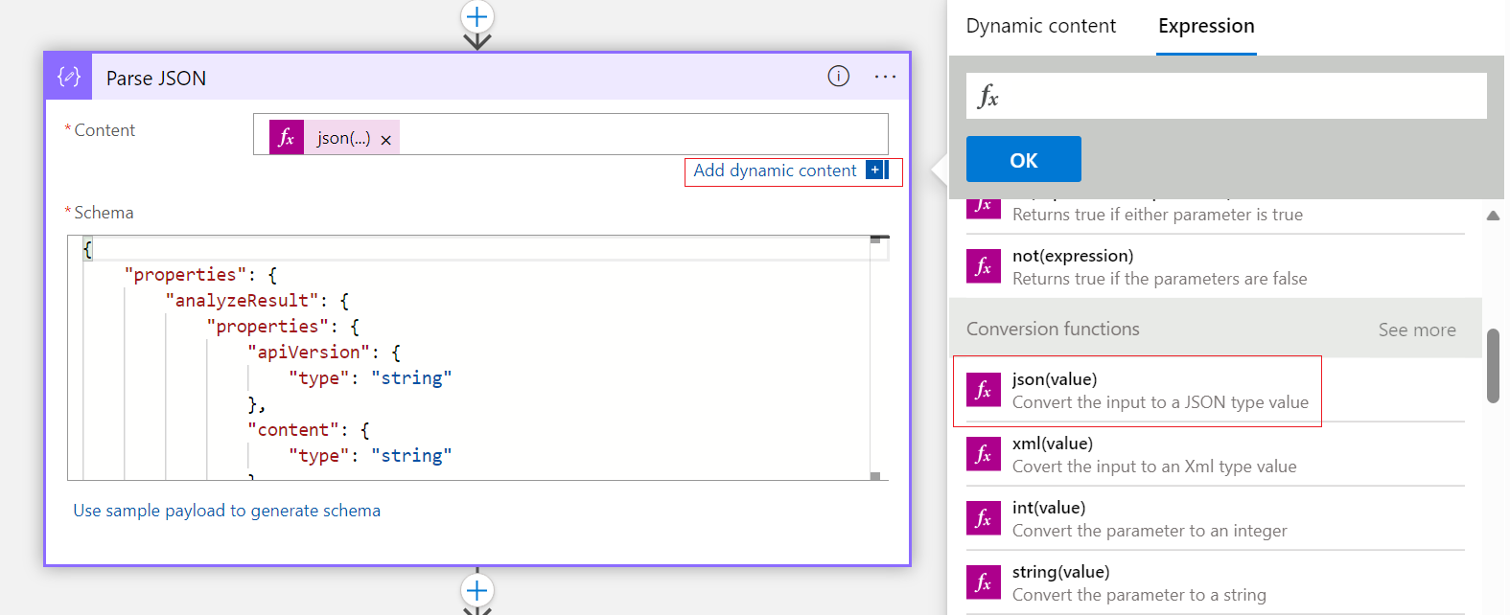

|  |  |
| --- | --- |
| Content | Json(body(‘Get_blob_content_(V2)’)) |
| Schema | <Copy and Paste your JSON Schema> |

1. Select the Action ‘For each’.

* On add dynamic content, select the target JSON object under Parse JSON for selected output.

|  |  |
| --- | --- |
| Select Output from previous step | <target JSON array/object> |

1. Click on ‘Add an Action’ within the ‘For each’ action.
2. Select the action ‘SharePoint - Create item’. Click on Add new parameter for each desired parameter in the data flow.

* On add dynamic content, select the target JSON object under Parse JSON for each parameter value. Example provided below.

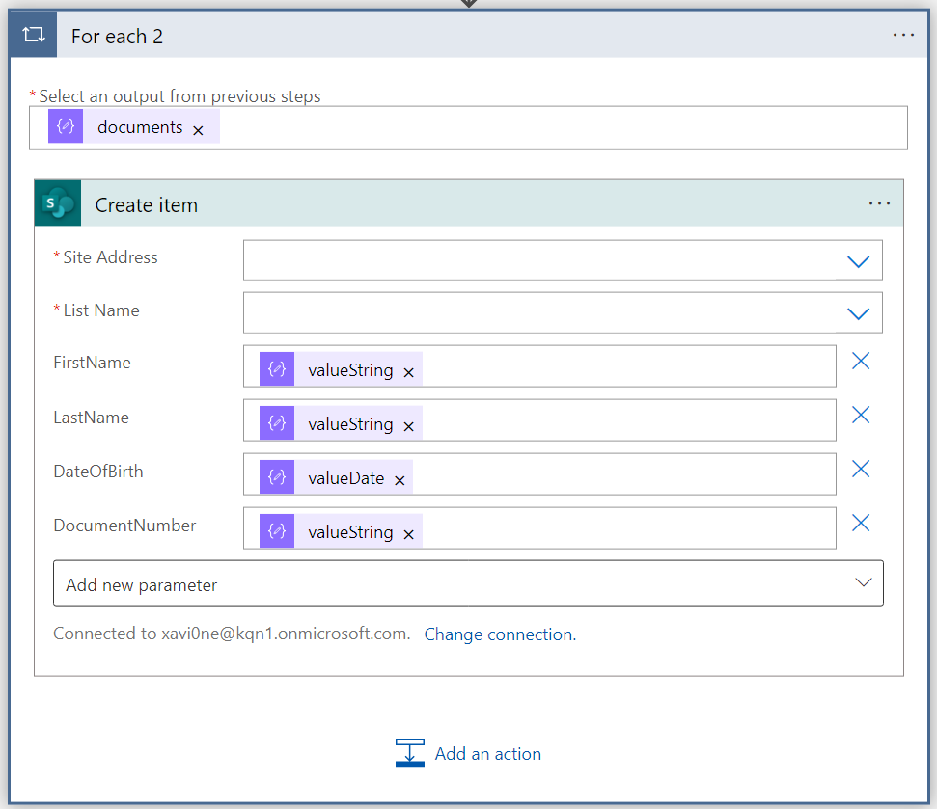

|  |  |
| --- | --- |
| Site Address | <SharePoint URL> |
| List Name | <your list name> |
| Parameters | <target parameter to map with JSON object> |

1. Click save at the top. Perform a test run by activating the trigger, which entails uploading a file to the target storage account container specified in the Trigger.

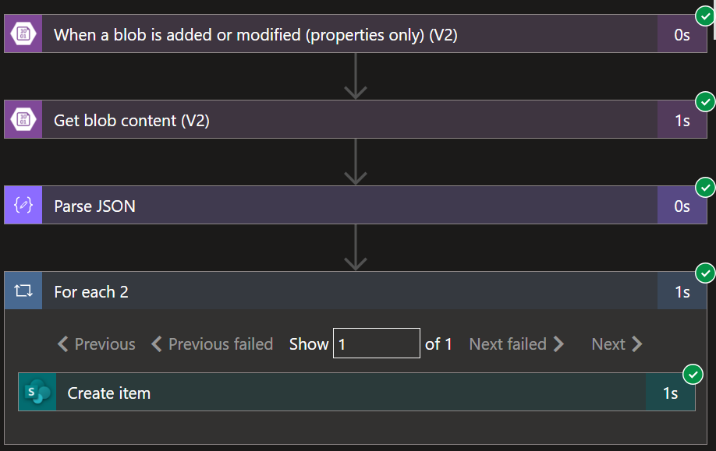

1. Validate the test run by logging into the SharePoint site specified in the SharePoint action and reviewing the list.

**LAB COMPLETE**

The outcome of this lab enhances proficiency in building an automated workflow with Azure Logic App for data processing in a secure by design approach.

The automation workflow is intended for JSON schema that does not change, but only the key values that change. Integrating the Logic App workflow will enable optimized business processing and offset the costs and labor of manual data handling.